CAN WE LEARN A SECOND LANGUAGE?
Sabrina Wang(100299727)
Gaganpreet kaur (100348334)
Amritpal singh
Parminder kaur (100363137)

Agenda
- Introduction
- Positive & negative effects of body language in business satiation
- Non verbal communication in job interviews
- How suppliers should use body language with customers ● Conclusion

Video
https://youtu.be/vicuZS0ChYQ

Introduction
- Body language affect the business situation and help people in business work.
- Also, sometime, body language may give some wrong information.
- Body language is the reflection of person character, we can judge

Internal
Pro:
- In the business situation, we can know the employees' exact thoughts through body language and use a better way to guide them correctly and improve their performance in work.
Con :
- Body language may provide us with some incorrect information that may influence people to make wrong judgments.

Internal
- The positive effects of body language in business satiation, mostly in the interview, employee or customer. By observing the body language of the audience, we can know their inner thoughts more clearly, it to help ourselves dominate the situation more quickly and occupy an advantageous position.
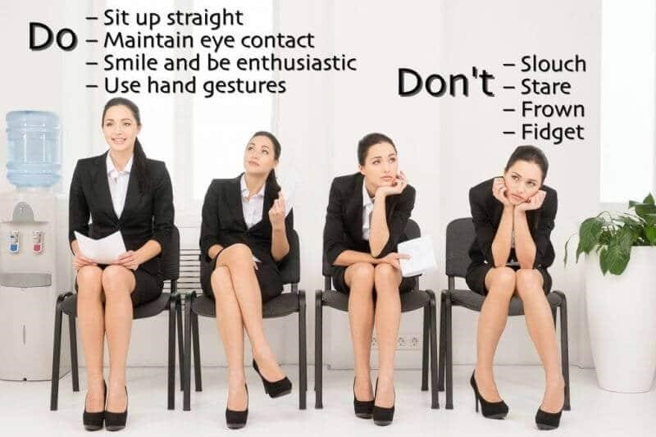
- However, incorrect body language, or your body language, can also expose problems.
Non verbal communication in selection of candidate for job interview.
- Body language of the candidate speculate the examiner rating, far away from the verbal clues.
- Physical appeal containing static prompts such as facial expressions,
- physical appeal containing such static prompts as facial experience, body shape, and preparing; and non-verbal practices, including such powerful signals as gestures, eye contact, grinning.
●

Pros of body language in job interview
- According to Bayes Straightforwardness, morality, alertness, geniality, and good humour reflect by the non-verbal clues like smiles, eye contact and Hand movements.
- Mehrabian(1969) identifies that eye contact and body expressions and gestural and facial clues result in extraordinary, and more effective and more promoter responses.
Con:
1. Surveys indicate that smiling during the middle of an interview can hinder success. Ruben et al. (2015)
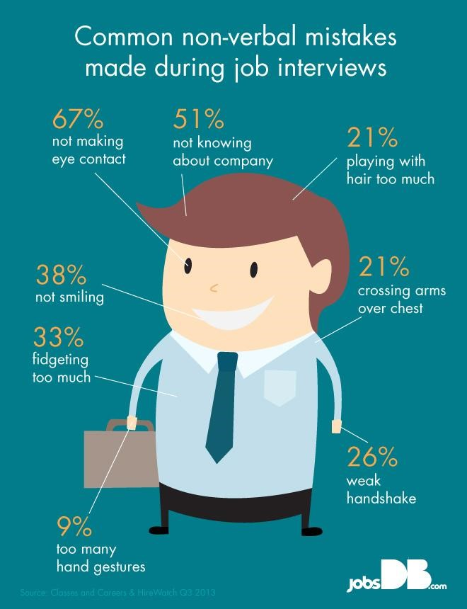
Mistakes in job interviews
How suppliers should use body language with customers ?
- benefits business individuals in winning over the customers,
- However, it can also lead to losing them, if used inappropriately.

Are there any Drawbacks?
- Overly emphasized negotiations with stubborn body gesture to win over the customer
- Putting pressure, creating a sense of urgency to make a rush decision, giving him limited options to choose from.
Conclusion:
- More benefits of using body language skills and negotiations in persuading customers positively and fewer cons which can be improved by practising more interaction skills
- Excess of everything is bad just like more smiling and more gestural expression can kick out the candidate from
- If used properly, body language, helps ourselves dominate the situation more quickly and occupy an advantageous position

Question?
& Thank You!

References
- McCormick, Jim & Karinch, Maryann. (2018). Body language sales secrets: how to read prospects and decode subconscious signals to get results and close the deal.
- Williams, Greg. (2016). Body language secrets to win more negotiations: how to read any opponent and get what you want.
- Purple moon promotional products (2019) https://www.purplemoonpromo.co.uk/news/body-language-for-business/#shownav.
●

